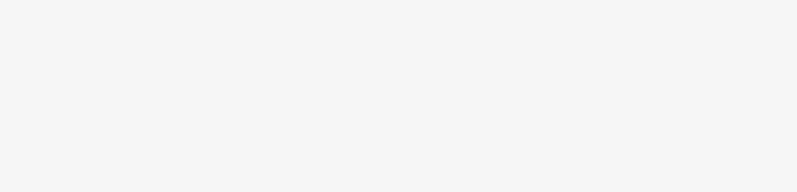

COVER LETTER

[01-12-2022]

[Hiring Manager’s Name]

[341 Company Address]

Company City, State XXXXX]

(xxx)xxx-xxxx

[hiring.manager@gmail.com]

Dear [Mr./Mrs./Ms.] [Hiring Manager’s Name],

I’m excited to submit my application for the [Position Name] position at [Company Name] I saw listed on [Website Name]. With a B.S. in Computer Science and over a year of hands-on experience building and testing apps for iOS and Android, I’m confident that I’d be a strong addition to your team.

While working as a software engineering intern at Macroworks in Ann Arbor, Michigan, I gained substantial experience identifying and fixing bugs, as well as coding in Java, Python, and Swift — all skills I’m confident would be useful at [Company Name]. Additionally, I leveraged my knowledge of Swift to help develop a productivity app for iOS that allows architects to render and edit blueprints.

Before working at Macroworks, I was a web development intern at Spin.io in Detroit, Michigan, where I was primarily responsible for fixing bugs, implementing UI enhancements, maintaining pages via WordPress, and using HTML, CSS, and JavaScript to build and enhance web pages. I also assisted in the development and rollout of a widget that helps cyclists locate their nearest bike lane, which is now one of Spin.io’s most popular products.

Interning at these companies provided me the opportunity to put my coding knowledge to work — developing and testing products for the marketplace. At both Macroworks and Spin.io I demonstrated my ability to hit deadlines, maintain strong attention to detail, and produce top-notch code. I’m confident my skills will be put to good use at [Company Name], and I look forward to speaking with you further about the [Position Name] position.

For your convenience, I’ve attached a resume that further outlines my relevant skill set, accomplishments, and experience. Thank you for your consideration, and I look forward to hearing from you soon.

Sincerely,

[Tulasi Sai Tharun Peram]